Initial Post
Brown (1994) presents the responses of 550 general practitioners (GPs) to 24 statements about intrapartum care. Table II contains useful information but is lengthy, making the main findings difficult to identify quickly. I therefore separated selected results into three areas and used graphs to make the findings easier to compare.
Barriers to Providing Intrapartum Care
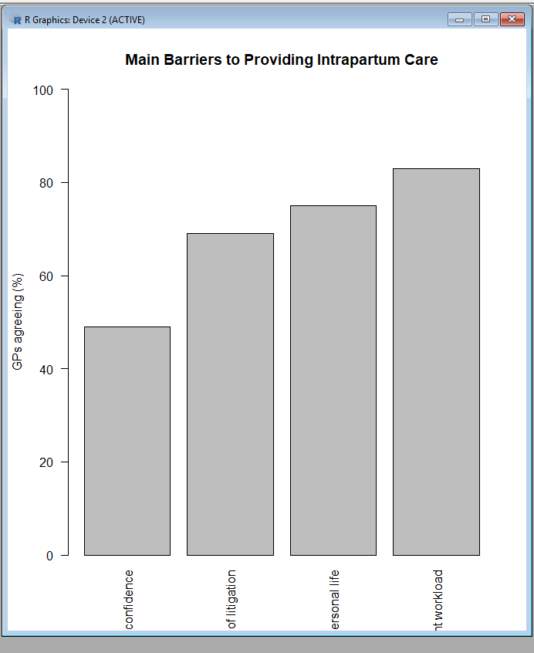

Figure 1: Main Barriers to Providing Intrapartum Care
Figure 1 shows that current workload was the most commonly reported barrier (83%), followed by disruption to personal life (75%), fear of litigation (69%) and lack of confidence (49%) (Brown, 1994).

Willingness and Competence
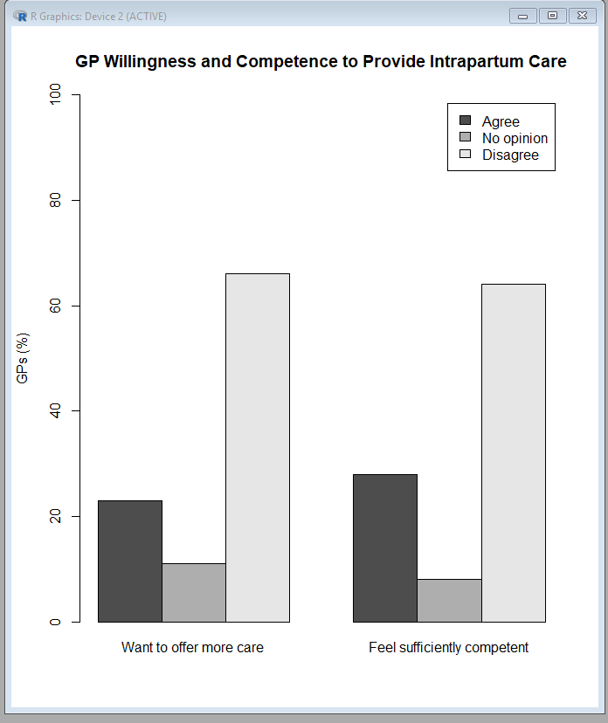

Figure 2: GP Willingness and Competence to Provide Intrapartum Care
Figure 2 shows that only 23% of GPs wanted to provide more intrapartum care, while 66% disagreed. Similarly, only 28% felt sufficiently competent to provide this care, compared with 64% who disagreed (Brown, 1994).

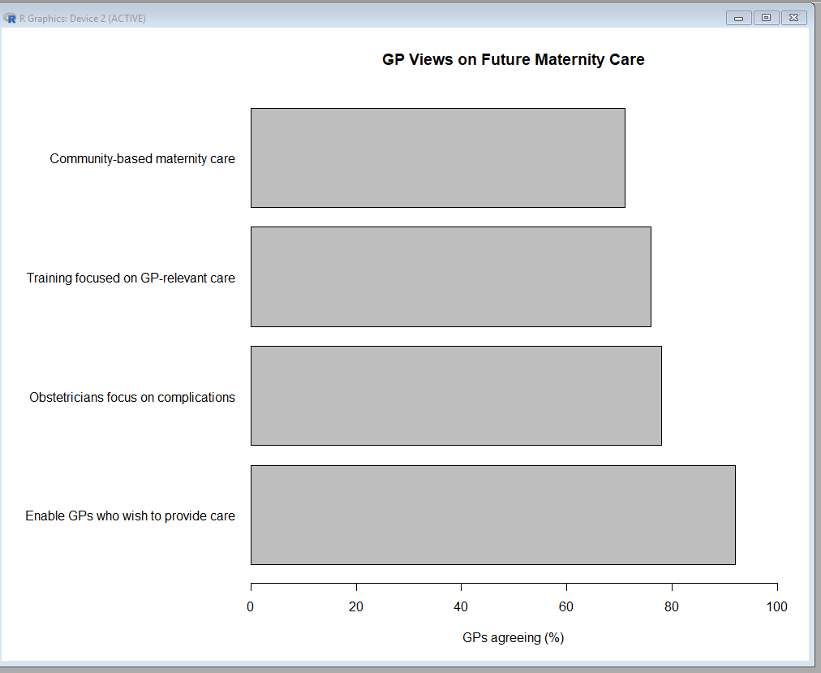
Views on Future Maternity Care

Figure 3: GP Views on Future Maternity Care
Figure 3 provides a different perspective. Although many GPs did not personally want greater involvement, 92% supported enabling GPs who wished to provide care throughout pregnancy, labour and the puerperium. There was also support for obstetricians focusing on complicated pregnancies (78%), GP-relevant obstetric training (76%) and community-based maternity care (71%) (Brown, 1994).

Reflection
This activity showed me that presenting all available numerical information does not necessarily make results easier to understand. Breaking Table II into themes and presenting key findings visually made the patterns and differences clearer. I also learned that graphs can make statistical findings more accessible, while the original table remains useful when exact figures are required.
Reference
Brown, D.J. (1994) ‘Opinions of general practitioners in Nottinghamshire about provision of intrapartum care’, BMJ, 309(6957), pp. 777–779. doi: 10.1136/bmj.309.6957.777.

